**Experiment No. 1.3**

**Student Name: Rishav Kumar UID: 22MCC20039**

**Branch: MCA - CCD Section/Group: MCD-1/ Grp A**

**Semester: III Date of Performance: 28th Aug 23**

**Subject Name: DevOps Process Automation Lab Subject Code: 22CAP-745**

1. **Aim/Overview of the practical:**

With an understanding of the theory and techniques that Maven uses to manage a project, we can now develop our own Maven project.

In this application, you have to create a simple adder that computes the sum of two integers. During this process, you will:

a. Generate a Maven project using the Maven command-line tool

b. Configure the pom.xml file

c. Create main and test source code files

d. Execute a Maven build

e. Execute the resulting JAR file

**Code for practical:**

* Open git bash and create a directory using ***mkdir project***
* Go to project using cd project
* Create a maven project using command

***mvn archetype:generate -DgroupId=ToolsQA -DartifactId=DemoMavenProject -DarchetypeArtifactId=maven-archetype-quickstart -DinteractiveMode=false***

* Import any java project using command

***git clone*** [***https://github.com/mariazeved088/artigo—boas—praticas—medium.git***](https://github.com/mariazeved088/artigo—boas—praticas—medium.git)

* Go to this directory using cd command

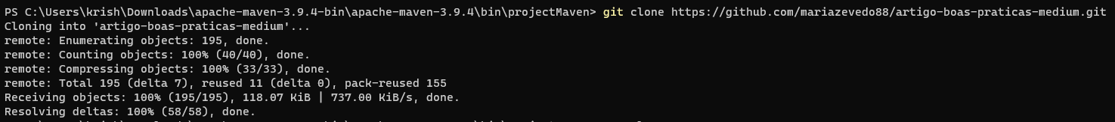

* Install java jdk and maven in computer
* Use following commands
* ***mvn clean:*** Removes build artifacts.

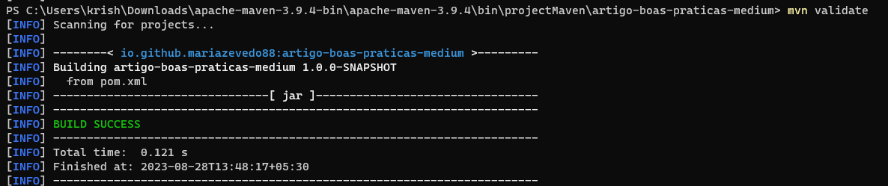

* ***mvn validate:*** Validates project configuration.
* ***mvn compile:*** Compiles source code.
* ***mvn test-compile:*** Compiles test code.
* ***mvn package:*** Creates distributable package.
* ***mvn verify:*** Checks package integrity.

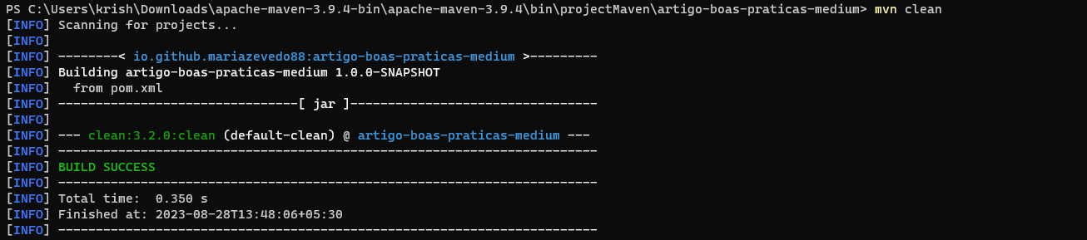

* ***mvn install:*** Installs package to local repository.

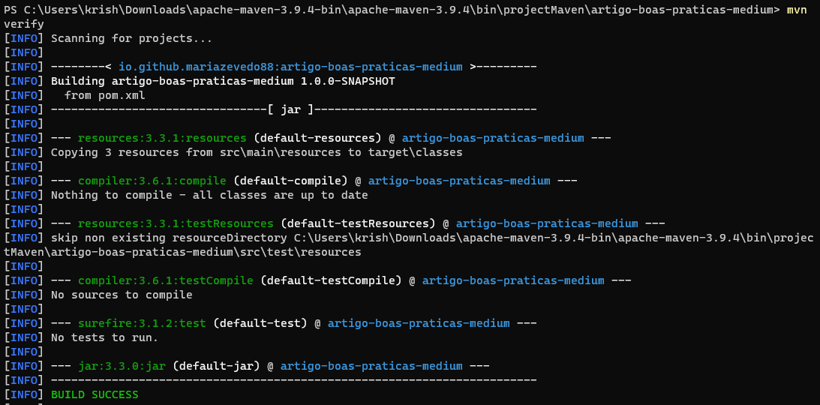

* ***mvn deploy:*** Deploys package to remote repository.

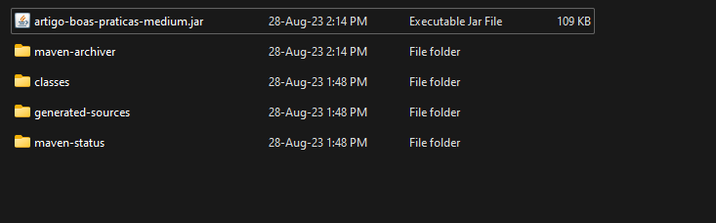

* Go to target folder and there will be JAR file execute it.

**************************************** **THE END** ***********************************************